Software Design Specification for

GIKI E-Delivery

Version 1.0 Date: Sunday, January 3, 2021

Supervisor: Group Members:

Sir Ahsan Shah Ahmed Nadeem 2018047

Saim Javed 2018320

M. Hassan Baig 2018284

Arsalan Ashraf 2018076

Revision History:

|  |  |  |
| --- | --- | --- |
| ***Revision History*** | ***Date*** | ***Comments*** |
| 1.00 | 1/3/2021 | Full working version |
| 2.00 |  |  |
|  |  |  |

Document Approval:

The following document has been accepted and approved by the following:

|  |  |  |
| --- | --- | --- |
| ***Signature*** | ***Date*** | ***Name*** |
|  |  |  |
|  |  |  |
|  |  |  |

Table of Contents

1. INTRODUCTION 5

1.1. PURPOSE 5

1.2. PRODUCT SCOPE 5

1.3. OVERVIEW 5

2. THE OVERALL DESCRIPTION 6

2.1. PRODUCT PERSPECTIVE 6

3. WORK BREAKDOWN STRUCTURE 6

4. Design 7

4.1 Layered ARCHITECTURAL DESIGN 7

4.2. Why we choose Layered Architecture Design? 8

4.3. MODULE IDENTIFICATION 8

5. 4+1 ARCHITECTURE VIEW MODEL 8

5.1. Use Case View 9

5.2. Logical View: 9

5.3. Development View 9

5.4. Process View 9

5.5. Physical View 9

5.6. User Interface Design 9

***Please note that there are many figures that you have to draw. I have only included two.***

List of Figures

Figure 1 Work Breakdown Structure 6

Figure 2 Layered Architectural Design Using Venn Diagram 7

Figure 3 4+1 Model 8

List of Tables

# INTRODUCTION

## PURPOSE

The purpose of this document is to provide detailed explanation and requirements’ analysis for the product ‘GIKI E-Delivery’ which is being developed as a web-app that will be hosted on GIKI’s local network and aims to offer various different functionalities to transform the on campus life with the help of GIKI’s local network infrastructure. It will also explain about the UI elements, features and interaction with the product.

## PRODUCT SCOPE

‘GIKI E-Delivery’ is a cross platform web-app that aims to transform the life of GIKI residents by providing certain set of functionalities. The set of functionalities

Include but are not limited to ordering things from Tuck Area, announcement page for societies/staff events and webinars.

Table 1: Terms used in this document and their description

|  |  |
| --- | --- |
| Name | Description |
| GIKI E-Delivery | The concerned platform under development |
| HTML | Hyper text markup language |
| JS | JavaScript |
| PHP | PHP is a widely-used, open source scripting language. |
| CSS | CSS stands for Cascading Style Sheets. |
| DB | Database |

## OVERVIEW

GIKI E-Delivery is a web based online platform that can be accessed from any device and from any browser. It aims to help the residents in having the ability to order anything online from the comfort of their rooms and to not have to wait in long call queues. It also records the spending and order time and date. Which can help you in managing your budget more wisely. You are also able to place the orders online from the available options provided by the stores. It will also help you in getting the cash ready on time about when the delivery is about to arrive.

# THE OVERALL DESCRIPTION

The description of the proposed system is given below. This description defines the product in different directions.

## 2.1. PRODUCT PERSPECTIVE

The design of this product is made by keeping in mind the life of an average person living in GIKI. The website will enable that user to order things from the tuck area and aims to help the residents by paying the bill online and track the orders they have made. Since the application is a web app, therefore it can be run on every browser and even on the cross-platform devices whether be it on desktop or on handheld devices like mobile phones.

# WORK BREAKDOWN STRUCTURE

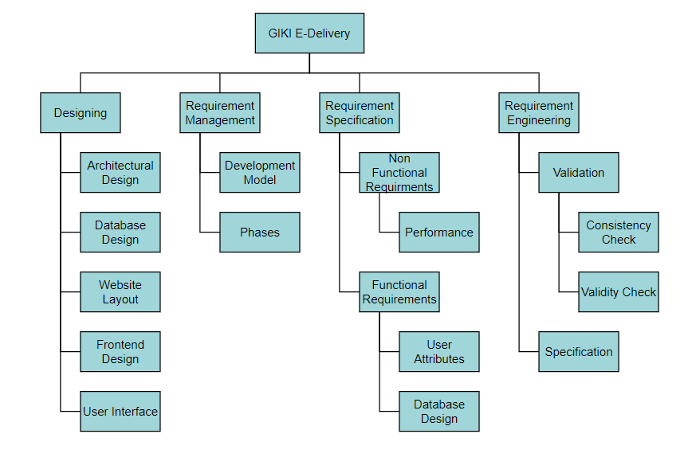

Figure 1 Work Breakdown Structure

Most of the work done was on agile approach as there are numerous features that had to be added and then tested. Later, many of them had to be altered therefore the agile approach had to be leveraged more. However, plan driven was also used in selection of the technologies and development of backend. The project was made with version controlling with the help of git and github and the testing of various components were carried out.

# Design

## Layered ARCHITECTURAL DESIGN

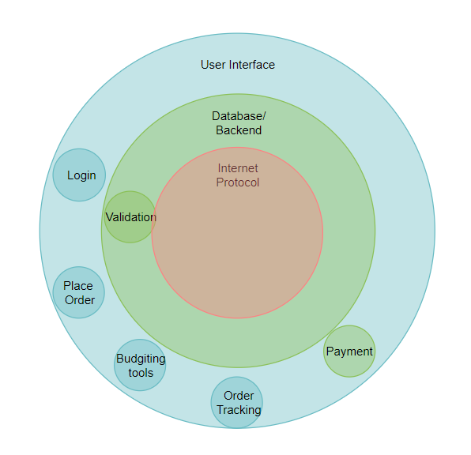

Figure 2 Layered Architectural Design Using Venn Diagram

## Why we choose Layered Architecture Design?

The software needs the architectural design to represent the design of software. IEEE defines architectural design as “the process of defining a collection of hardware and software components and their interfaces to establish the framework for the development of a computer system.”

In layered architectural design, several different layers are defined with each layer performing a well-defined set of operations. Each layer will do some operations that becomes closer to machine instruction set progressively.

The users will be able to interact with different components of the website with the help of the top level user interface that is provided.

## MODULE IDENTIFICATION

The modules are:

* Login/Register
* Place Order
* View status
* Track order
* Budgeting
* View Invoice
* Online payment Gateway

# 4+1 ARCHITECTURE VIEW MODEL

In this section, you draw the architecture using the views defined in the “4+1” model.

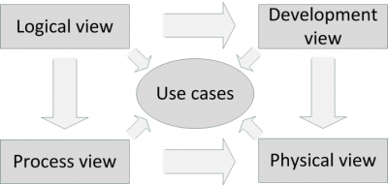

Figure 3 4+1 Model

## Use Case View

This is a list of use-cases that represent major functionality of the final system:

## Logical View:

## Development View

## Process View

## Physical View

## User Interface Design